**The Core Terraform Workflow**

The core Terraform workflow has three steps:

1. **Write** - Author infrastructure as code.
2. **Plan** - Preview changes before applying.
3. **Apply** - Provision reproducible infrastructure.

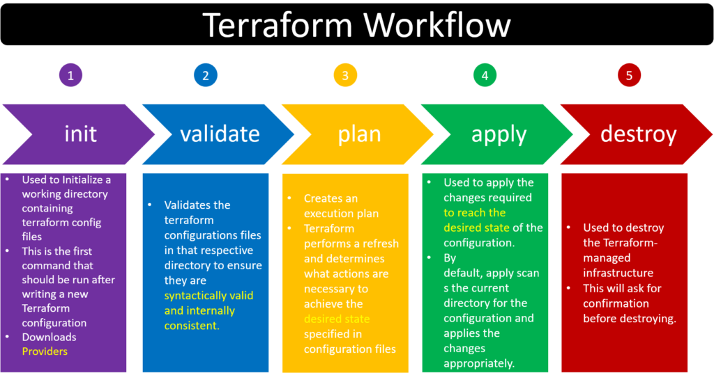

Fmt: for checking format

Validate: it validate syntax like { }